# **AWS :**

# 

# **AWS Backup - On-Demand DynamoDB and EC2**

Step 1: login to aws management console and navigate to dynamoDB console.

Step 2: create a dynamoDB table and create 2-3 items in it .For demo purposes, we upload only 2-3 items but we can upload more items as you have.

Step 3 : after dynamoDB table,move to ec2 dashboard and launch an linux ec2 instance with default settings.

Step 4: after ec2 instance ,move to “AWS backup” and create an “on-demand backup”.

Step 5: To create an on-demand backup ,click on aws backup dashboard select “create on-demand backup”.

Step 6: To create on demand backup :-

* choose the resource type “dynamoDB”
* select your dynamoDB table in “table name”
* Select the “customize backup window” and select the time period from when you want to start and complete the backup.here we select start within “1 hour” and complete within “2 hours”.
* Choose the transition to cold storage as “never”
* “Retention period” kept it by default.
* For backup vault ,create a new backup vault .To create a vault,name the “bucket vault name” and choose the default “encryption key” and then click on “ create backup vault”.
* After that select the “default role” in IAM role and click on “create on- demand backup”.

Step 7 : Now go to aws backup jobs and you will see a job will start creating .That is the backup job of dynamoDB resource.

Step 8: Now again create “on demand backup” .But this time for ec2 instance resource and select your ec2 instance .Select the configuration as we selected in dynamoDB and select the same vault that we created at the time of dynamoDB resource.

Step 9 : Now go to “aws backup jobs” ,you will see 2 jobs are created ,they both are related to our backup resources.

Step 10 : wait for some hours,as backup jobs take time to complete.when the backup job status changes to “ complete” then you can go to dynamoDB dashboard and table backup in backup section.a backup is created there.

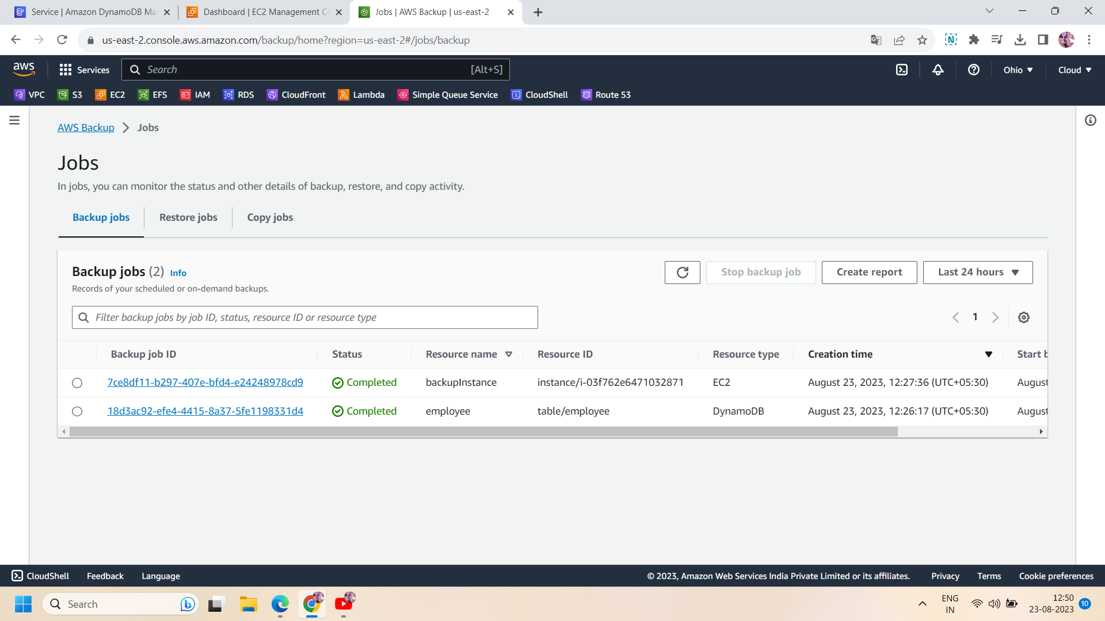

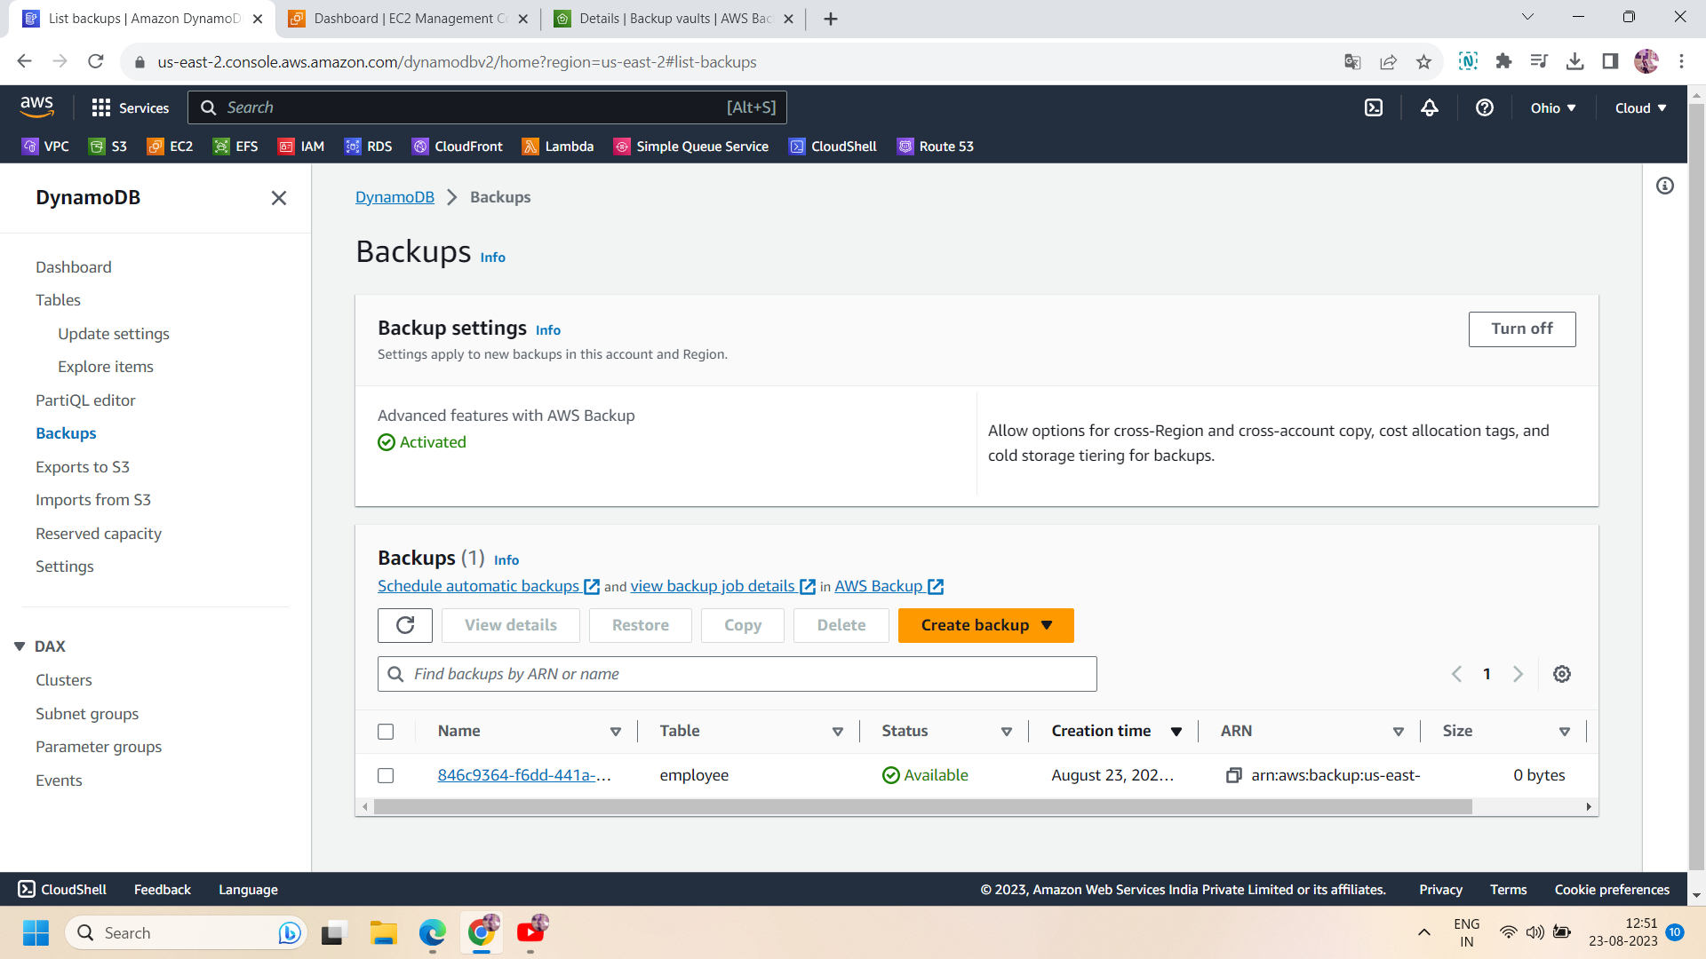

Step 11: Now go to the ec2 dashboard and move to ‘AMI’ ,you will get the AMI of your ec2 created by aws backup and in the snapshot you will see a snapshot of your ec2 instance ,also created by aws backup.

